莲蓬头 手把
亞洲采新有限公司 熊小姐(Regina)
EMAIL: mira@ozeol.com
QQ: 2018536148
电话: (86) 400 6800 406
http://www.ozeol.com/en/
Product family |  | Product type
Plumbing & Sanitary |  | Hand's shower
PICTURES
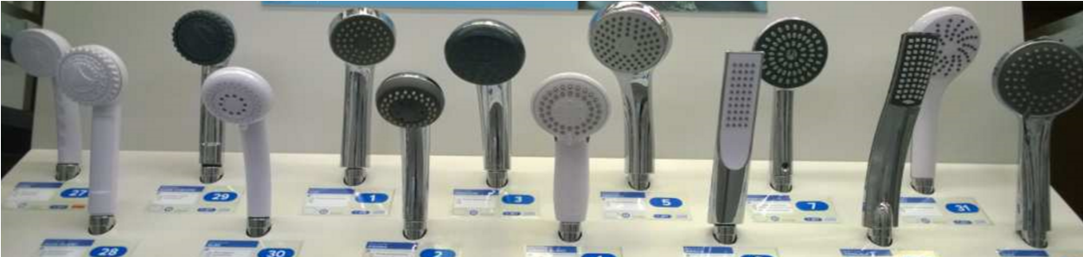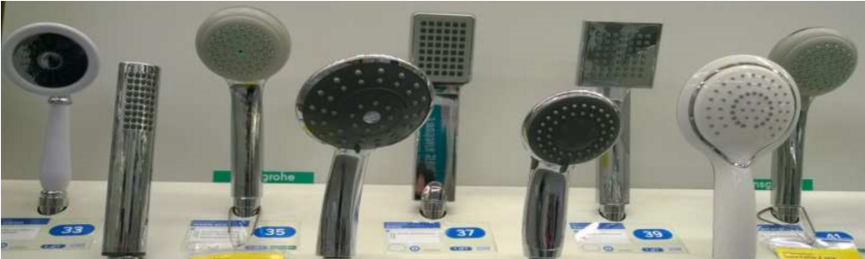
French market details
Products represented on the French marketplace with diversity of design and number of functions.
Those products should be replaced every 3 or 5 years.
Product seasonality : Ideal sales period : any time
Packaging details | Dubble blister
Product description  Hand's shower 1 fonction |  |  | Product's specificities modifying basic price level
 |  |  | Fonctions | 1/2/3/5/8
 |  |  | Head's size | more than D15cm
Additional information
Potential quantity |  | 19600 with 6/7 differents products (fonctions and design)
Mandatory standard and quality check request

