Product sourcing details
联系; 亚洲采新REGINA
QQ: 2018536148 | Email: mira@ozeol.com
Product family : GARDEN | Product type : DOG CARRIER BAG
 | PICTURES
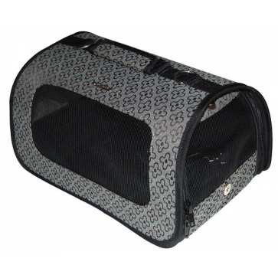 | 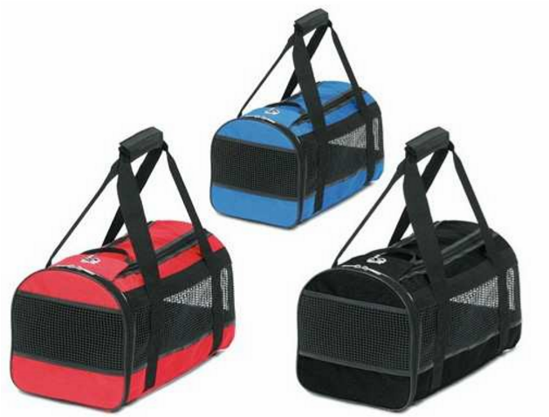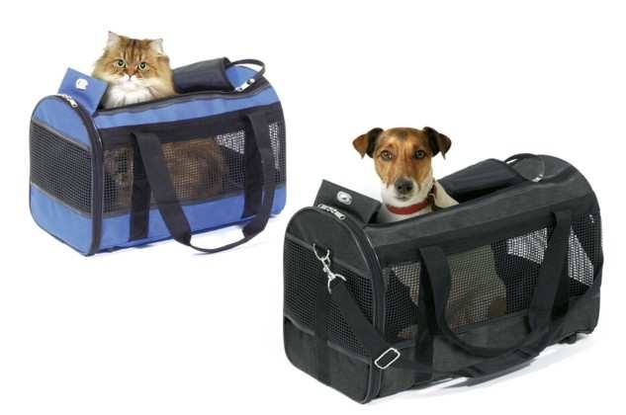
these products may be fou  The important's informations : material, | French market details nd in specialized's stores, GSB, GSA, discounters. desin, width (min 25cm), lenght (min 45cm), height (min 30cm).
Product seasonality : during the whole year | Ideal sales period : during the whole year
Packaging details | carboard box with picture and product's informations.
Product description  for example : dog carrier bag 25*45*30cm |  | Product's specificities modifying basic price level
 |  | material
 |  | size
 |  | design
Additional information
Potential quantity
Mandatory standard and quality check request

