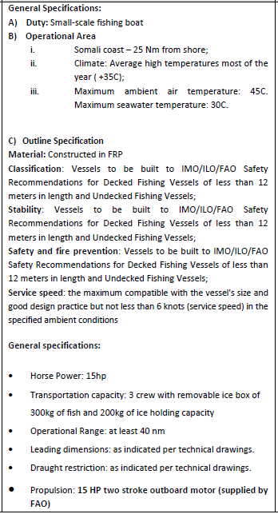

**TECHNICAL DRAWINGS FOR SOM750**



The vessels will be open boat, with no sun roof and no internal ice box, but with a removable ice box.



The vessels shall be fitted with outboard motor well at the transom, with suitable transom height of outboard motor leg of 20inch/500mm. Under the outboard motor well and under driver seat, plus forward anchor bow compartment to be filled with polystyrene floatation and sealed water tight.



All vessel to have a skeg manufactured and fully glassed to the bottom of the hull at the transom. The skeg shall be approximately 1.2 meters long x 135mm high and 30mm thick. The forward edges to be well shaped and faired to allow good water flow to the propeller.



The vessels shall be supplied to the assembly/completion of manufacture site as a kit set system. The hull skin manufactured in the contractor’s factory and shipped to the location with all frame molds, etc. to ensure a professional assembly can be conducted at the location and youth can benefit from the experience of manufacture of the craft in their communities.

The contractor must supply on the basis the equipment remains with the trained youth on completion of the contract.

1. 240volt generator, a four stroke Yamaha generator or similar quality. A low quality generator is not acceptable.

2. All electrical tools all hand tools and all materials and equipment to complete the craft, ready for operation.

3. All staff work place health and safety equipment must be supplied and youth under training must be instructed to use safety equipment.