车用宠物垫子
联系: 亚洲采新 REGINA
EMAIL: mira@ozeol.com
QQ: 2018536148
 | PICTURES
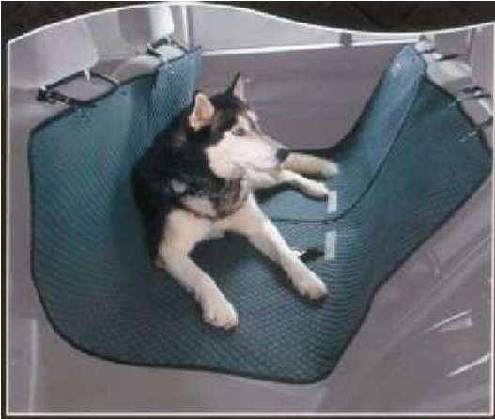 | 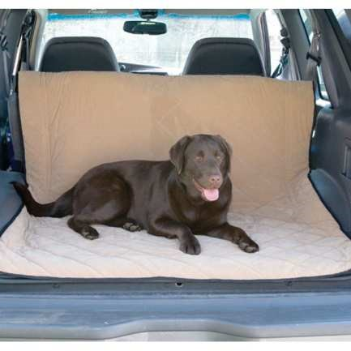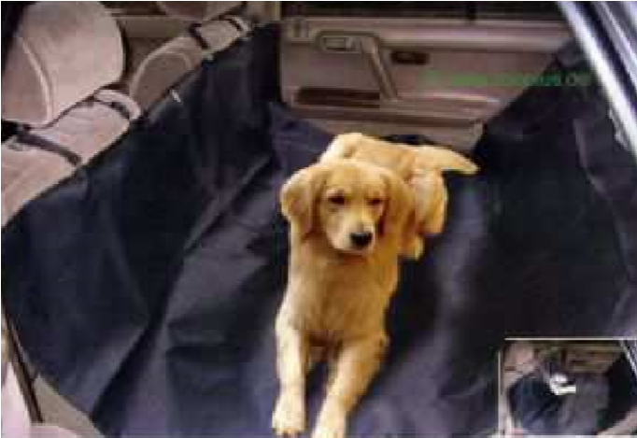
these products may be fou  The important's informations : siz | French market details nd in specialized's stores, GSB, GSA, discounters.  e, material (polyester, nylon, water-repellent), padding, zip
Product seasonality : during the whole year | Ideal sales period : during the whole year
Packaging details | cover with picture and product's informations.
Product description for example : |  | Product's specificities modifying basic price level
Product description for example : |  | size
Product description for example : |  | material
Product description for example : |  | padding
Product description for example : |  | zip
Additional information
Potential quantity
Mandatory standard and quality check request

