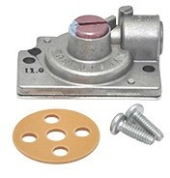



1751-013

*1751 Regulator Series*

The Robertshaw® 1751 Series Add-on Pressure Regulator Kits are available for use on the following factory model types: 7000, 7010, 7100, 7200 and 7222. Each 1751 pressure regulator kit provides straight-line regulation and includes all the necessary parts including instructions to convert a specific factory model gas valve.

Features and Benefits

* Converts natural gas to LP
* Not for use with hydraulic models which cannot be field converted
* Includes all necessary parts for easy regulation conversion
  + ATTRIBUTES

# Series Application Add-On Pressure Regulator Kit

**Adjustable WC Pressure Low/High 8" / 12"**

**Regulator Type 11.0" WC LP Gas**

**Except hydraulic models which**

**cannot be field converted**

**Comments**

中文网站

<https://www.robertshaw.com/zh-CN/ProductDetail.aspx?id=2147493621>