Section II: Schedule of Requirements
- Technical specifications for Goods and Comparative Data Table

UNOPS minimum technical requirements | QTY | Unit | Sample Picture for Illustration Purpose Only
Supply an Electric powered fork lift trucks with the minimum below specifications:  * 4-wheel chassis, 80 volts, front wheel dual drive  * AC traction and pump control  * Load Capacity : 3000 KG  * Basic overhead guard  * 2 x AC traction motors, 8 kW  * lifting Height : 3000 mm  * Forks with a length of 1200 mm, equipped with load backrest  * AC pump motor 25,5 kW  * Key pre-set economy or high performance mode (ECO / PRO)  * Pneumatic shaped solid tires (super elastic)  * Variable hydraulic speed control functions  * Wet disc brakes  * Full-suspension basic vinyl seat  * LED work lights (2 at the front and 1 at the rear)  * Tiltable steering column  * TruckTool setup and diagnostics  * Principal components with IP 54 rating  * DIN battery connectors on frame  * Reverse drive horn button  * with 80 Volt charger , 100 Amp  * Battery door detection sensor  * Year model : not older than 2018  * one year warranty from manufacturer defects  * Including all custum fees, registration fees, mandatory insurance fees and transportation fees until Marka VTC at Marka | 1 | No | 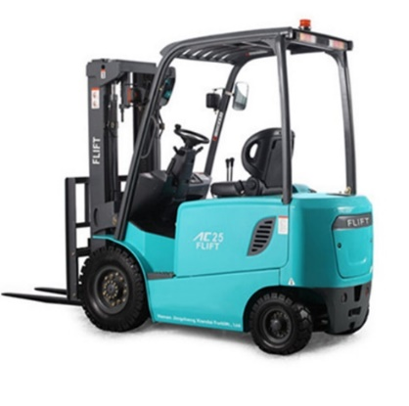

- Delivery requirements and Comparative Data Table

UNOPS Requirements |  | Is quotation compliant? Bidder to complete | Details  Bidder to complete
Delivery time | Bidder shall deliver the goods before 01-February-2019 | ☐ Yes ☐ No | Insert details
Delivery place and Incoterms rules | Marka Vocational Training Centre- Amman on DAP basis as per Incoterms 2010 | ☐ Yes ☐ No | Insert details
Consignee details | Marka Vocational Training Centre in Amman | ☐ Yes ☐ No | Insert details
UNOPS Right to vary requirements | At the time the Contract is awarded, UNOPS reserves the right to vary the quantity of the goods and associated services specified above, provided this does not exceed +/- 20%, without any change in the unit prices or other terms and conditions of the RFQ. | ☐ Yes ☐ No | Insert details

