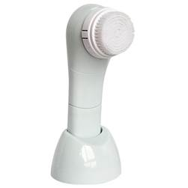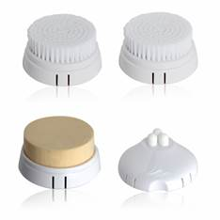
Beauty instrument
Description: Super Cleanse
Features:
1. Cleansing principle: releasing a gentle, frequent and slight shock to clean face, together withmassage, can more effectively and thoroughly remove stubborn dirt, grease and residual
makeup inside pores so as to achieve the effect of deep cleansing.
2. Beautiful, practical and affordable with novel design and exquisite packing; light and small, easy to carry; easy and safe to operate.
3. Accompanied by four replaceable massage heads with different effects, you are free to choose them according to your requirement, suitable for various parts of the body.
4. Various functions: deeply cleaning skin, effectively exfoliating of dead skin cells to reveal a radiant, youthful skin, stimulating blood circulation, eliminating fatigue and relieving pressure.

1.Power supply:3V,2 pcs AA batteries (not included)
2.Unit size:168*55*55mm
3.Unit weight: around 110g
4.Material of main case:ABS
5.Water-resistant for bathroom usage
6.Gift box size:205*140*55mm
7.Accessories: 4 replaceable applicators(sensitive brush,dermabrasion brush,sponge,wrinkle reducer),instructions
8.Package:24pcs/ctn,N.W.:6kg,G.W.:7.6kg,Meas.:425*350*300mm
MOQ : 1000PCS USD3,20.

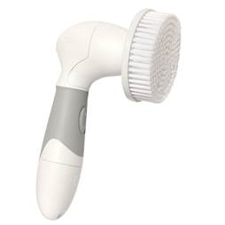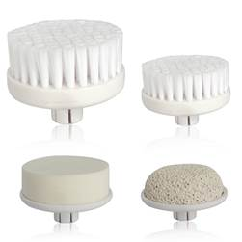

cosmetic instrument
Model: ABB201
Description: waterproof cleaning massager
Features:
1. Water resistant.
2. Lightweight and compact.
3. Anti-slippery handle, convenient for usage in bath room.
4. Accompanied by four replaceable massage heads with different effects, you are free to choose them according to your requirement the arbitrary choice, suitable for the various parts of the body.
5. Various functions: deeply cleaning skin, effectively exfoliating of dead skin cells to reveal a radiant, youthful skin, stimulating blood circulation, eliminating fatigue and relieving pressure.

1.Power supply:6V,4pcs AA batteries (not included)
2.Unit size:176.5*76*47mm
3.Unit weight: around 128g
4.Material of main case:PP
5.Waterproof with stong power:convenient for bathroom usage
6.Gift box size:195*146*51mm
7.Accessories: 4 replaceable applicators(big brush,face brush,pumice,sponge), instructions
8.Package:24pcs/ctn,N.W.:6.5kg,G.W.:7.5kg,Meas.:410*310*315mm

