    DC-motor

         22VDC(Yes 22V)

-         4000rpm @ 1.2Nm

-         Ball bearings (needed because we have big axial force of 3600N!)

-         IP20 is OK

-         Ins. Class F

-         Suppression inside

-         Life time 1000h requested

-         S2 – 30min duty

-       with wire 150mm

-         24V brake, 3Nm (must be close if power OFF) with hand using

Shaft must be as here:

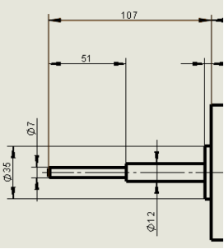

there is no special request for the size. You can use any standard size as 78mm or 80mm or 83mm.

Here example of a DIA80mm

​