RIB Project

An inflatable boat to be used for tours. Must be simple, small, eye worthy, maintained easy and durable. Should mimic current companies doing the same tour kayakingpuertorico.com and miniboatadventures.com

Key features:
Bright Color
Seating for 2 aft, 1 at front of console, 1 forward.
Minimum length 13’ , max length 15.5’
Made from Hypalon, not PVC (durability issue)
Should not have step in rear of pontoon. Should be rounded or conical shaped.
Max HP rating at least 40HP up to 50HP
Fiberglass deck configuration, not aluminum.
Storage compartment in bow

Major Concerns
Sourcing an acceptable rear seat
Sourcing an acceptable steering console.
Prefer console with built in seat
Placement of fuel tank
Keeping weight forward to prevent bow-rise at slow speeds. (battery, fuel, cooler, passengers)

BOATS USED BY CURRENT TOUR COMPANIES
The boats below are 14’ made in Venezuela and sold under the NAUTICA CARIBE brand name.
I would be fine purchasing these boats as is. The distributer is in Miami.
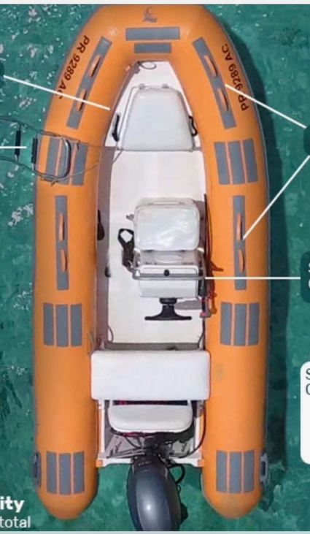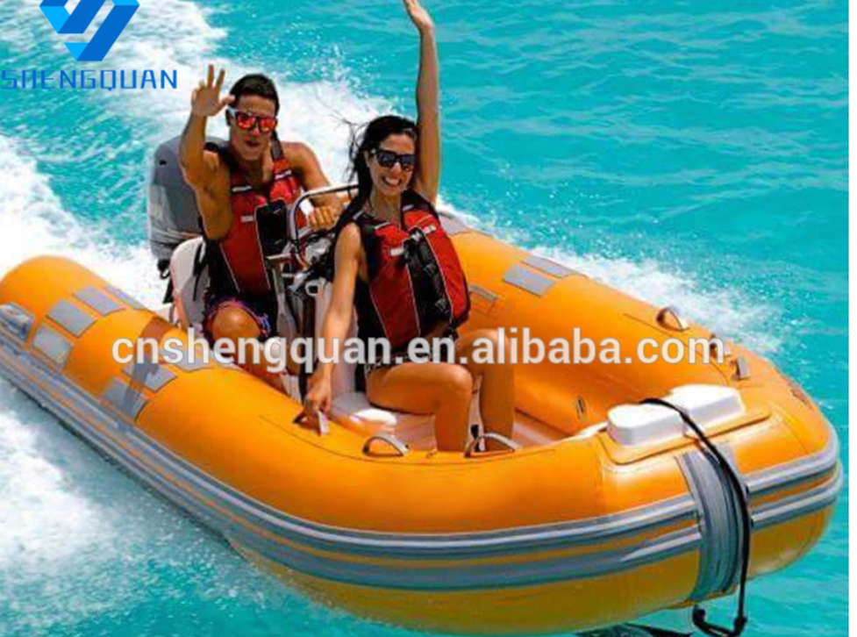

The Caribe version of these is the T-14. Even making sure they are suppled as pictured with the US supplier is difficult. I have been quoted $7200 each for qty of 5 or more.
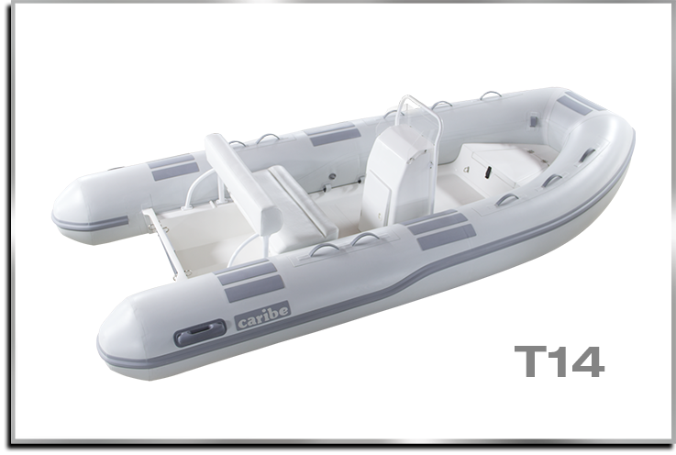

Links to boats I’ve favorited on Alibaba, all for various reasons. Alibaba is confusing, it’s like there’s a picture and a description and then 20 other possibilities all within the same item. Hard to know what you are getting.

https://www.alibaba.com/product-detail/CE-approved-factory-supply-390cm-rigid_60759737544.html?spm=a2700.9114905.0.0.Sh2Gho

https://www.alibaba.com/product-detail/rib-420-fiberglass-boat-for-sale_60372676846.html?spm=a2700.9114905.0.0.Sh2Gho

https://www.alibaba.com/product-detail/2018-New-Design-High-quality-Inflatable_60302157002.html?spm=a2700.9114905.0.0.Sh2Gho

https://www.alibaba.com/product-detail/4-2m-6-people-fiberglass-open_60396411638.html?spm=a2700.9114905.0.0.Sh2Gho

https://www.alibaba.com/product-detail/2019-Newest-Orca-Tube-Fiberglass-Dinghy_62204078686.html?spm=a2700.9114905.0.0.Sh2Gho

https://www.alibaba.com/product-detail/China-High-Quality-PVC-Hull-Material_60761795497.html?spm=a2700.9114905.0.0.Sh2Gho

