Form B: Price Schedule Form
Bidders shall fill in this Price Schedule Form in accordance with the instructions indicated.

RFQ reference no: RFQ/2019/9372

Currency | USD

Item No | Description | Qty | Unit price [DAP] | Total price [DAP]
LOT 1 – Inverter & Accessories
1.1 | INVERTER 9 – 10 KW | 2 | insert | insert
1.2 | BATTERY TROJAN 6V/225A | 48 | insert | insert
1.3 | ACCESSORIES FOR INVERTER INSTALLATION (As per schedule of requirements) | 1 | insert | insert
1.4 | CHARGE CONTROLLER | 1 | insert | insert
Total Price – DAP  3, Rue Marion, Péguy-Ville; Port-au-Prince – Haiti |  |  |  | insert

Payment terms 30 days accepted:☐Yes

Bidder’s discount for accelerated payment: ____% of total firm price for each calendar day less than thirty (30) days

List of subcontractors or suppliers

Bidder must identify the names of all subcontractors/suppliers who will be providing good/services under this Contract and the type of work being subcontracted, if applicable.

- _[Full legal name and address of subcontractors]___________

- _________________________________________________

- _________________________________________________

I, the undersigned, certify that I am duly authorized by [insert full name of Bidder] to sign this quotation and bind [insert full name of Bidder] should UNOPS accept this quotation:

Name : _____________________________________________________________

Title : _____________________________________________________________

Date : _____________________________________________________________

Signature : _____________________________________________________________

Form C: Technical Quotation Form

RFQ reference no: RFQ/2019/9372
Name of Bidder: [insert name of Bidder]

Bidders are required to complete the Comparative Data Tables included in Section III: Schedule of Requirements to demonstrate compliance with UNOPS requirements and insert them below.Bidders are NOT allowed to make any change in the “UNOPS requirements” columns of the Comparative Data Tables. Such changes might disqualify your quotation.

Technical specifications for Goods and Comparative Data Table:

***The bidder shall submit detailed specifications and pictures of the proposed product.

Item No | UNOPS minimum technical requirements | YES () NO () | Your offer  (Please fill in):
LOT 1 – Inverter & Accessories
1.1 | Inverter  Basics Parameters requested:  - 9 – 10 KW  - Hybrid or Off grid Inverter/charger. The inverter will be used between local electrical power generators and the facilities  - Brand Requested : OutBack, Schneider, Magnum, Xantrex or Equivalent  - In case of Equivalent products, the vendor MUST provide the Contacts of the Official Brand distributor in Haiti for the after sales services related to the products offered.  - Pure sinewave, True sinewave  - Input AC : 210Vac, 60Hz , 3 Phases  - Input DC: 24V dc or 48Vdc preferable  - Output AC: 210Vac, 60Hz , 3 Phases  - Output AC Power 8 – 10kW  - Vendor Guarantee: 1 year  - Installation and Operation Manual  - Service/Technical/Maintenance Manuals | YES() NO()
1.2 | Battery  - Trojan type or equivalent;  - 6V, 225 Ah,  - Lead Acid;  - Deep Cycle flooded;  - ELPT or EHPT terminal configuration complete of nuts  - In case of Equivalent products, the vendor MUST provide the Contacts of the Official Brand distributor in Haiti for the after sales services related to the products offered. | YES() NO()
1.3 | Accessories for Inverter Installation  - Copper bar with Clamp for grounding (5 feet length) (Qty: 2);  - Copper welding cable 1/0 (100 feet length) (Qty: 1);  - Compressible terminals for 1/0 welding cables (Qty: 80);  - Copper welding cable 4/0 (250 feet length) (Qty: 1);  - Compressible terminals for 4/0 welding cables (Qty: 40);  - Heavy Duty manual adjustable Wire terminal crimping Tools (preferable crimping range from size 350MCM to 1/0 (Qty: 1). | YES() NO()
1.4 | Charge Controller -  - Battery Monitoring device  - Provide indicative data of the battery  - Compatible with the batteries and inverter proposed,  - Voltage range: 6Vdc – 60Vdc  - Current rage : 10A – 1000A  - Capacity range: 200Ah – 2500Ah  - System autonomy with load (Time or % of residual capacity of the batteries;  - Temperature range: 15 - 60⁰ C | YES() NO()
 | Illustrative Pictures: for Illustration only  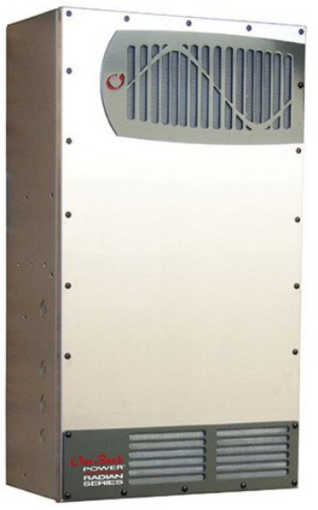  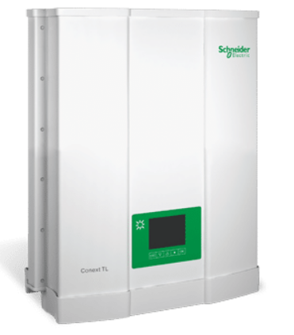  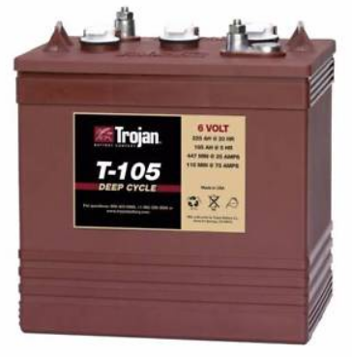 | YES() NO()
Delivery time 4 weeks. Please specify your offered delivery time:
Country of origin: Please specify

Delivery requirements and Comparative Data Table:

UNOPS Requirements |  | Is quotation compliant? Bidder to complete | Details  Bidder to complete
Delivery time | Bidder shall deliver the goods within four (4) weeks after Purchase Order signature. | ☐ Yes ☐ No
Delivery place and Incoterms rules | UNOPS Office,  3, Rue Marion, Péguy-Ville;  Port-au-Prince, Haiti.  Incoterms 2010 - DAP | ☐ Yes ☐ No
Freight Forwarder | The bidder should dispose a locally registered freight forwarder to clear and deliver the goods to UNOPS premisses.  UNOPS will only provide franchise letter approved by the customs authorities, | ☐ Yes ☐ No

FormD: Previous experience form

RFQ reference no: RFQ/2019/9372
Name of Bidder: [insert name of Bidder]

Description of services/goods | Country | Total amount of Contract | Contract Identification and Title and  Contact details of Client  (Name, Address, telephone, email, fax) | Year project was undertaken

Name : _____________________________________________________________

Title : _____________________________________________________________

Date : _____________________________________________________________

Signature : _____________________________________________________________

75 00ax: +45 45 33 75 01

