金属椅(靠背)tolix chair
亞洲采新有限公司 熊小姐(Regina)
EMAIL: mira@ozeol.com
QQ: 2018536148
电话: (86) 400 6800 406
http://www.ozeol.com/en/
Product family |  | T |  | ype of product
Furniture |  | M |  | ETAL CHAIR
 |  | PHOTOS / PICTURES
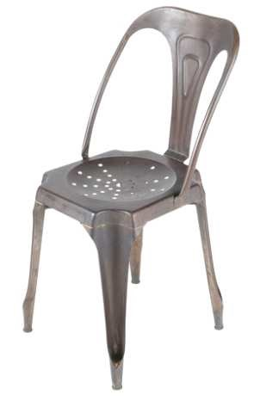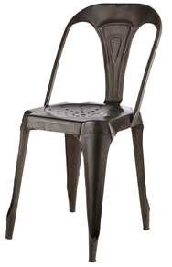 |  | 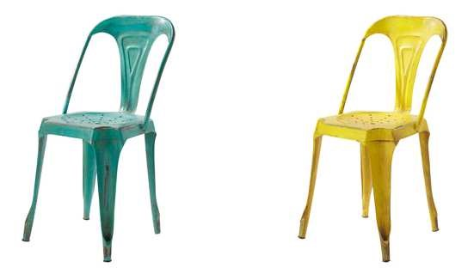
 |  | Fr |  | ench market informations
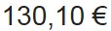 |  | 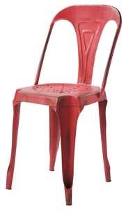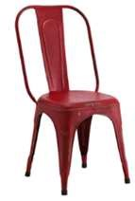
Ideal period for the stores |  | NONE - the is no se |  | ason for this product
Packaging Must be in one carton with informations drawings.or written very cle |  | manual instructions as clear as th  arly in french. A picture in color i |  | e one done for ikea furniture meanning with  s a real plus for sales
product description  METAL FINISHING OBSOLETE OR METAL FI  LACQUER  COLOURS EASY AND TRENDS: GREY META RED.  SEAT HEIGHT: ENV. 45CM. |  | NISHING L, BLACK, | eleme | nts changing the price level
 |  | NISHING L, BLACK, | Finitions
 |  | NISHING L, BLACK, | Color
 |  | NISHING L, BLACK, | Quality of iron
additional information |  | None
Potential quantity |  | Around 15.50€ per piece and 4400 pièces
Mandatory standard
and request for None quality control

