沙发凳
亞洲采新有限公司 熊小姐(Regina)
EMAIL: mira@ozeol.com
QQ: 2018536148
电话: (86) 400 6800 406
http://www.ozeol.com/en/
Product family | T |  | ype of product
Furniture | FLE |  | XIBLE POUFFE
 | PHOTOS / PICTURES
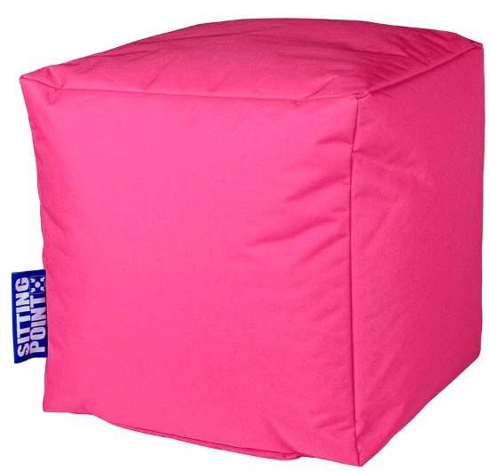 | 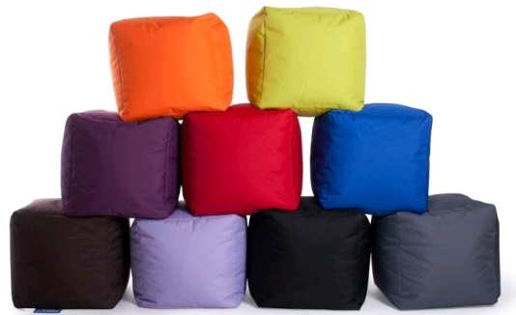 |  | 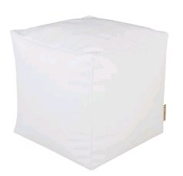
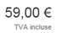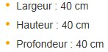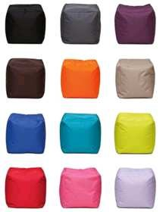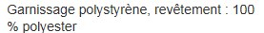 Fr | ench market informations  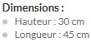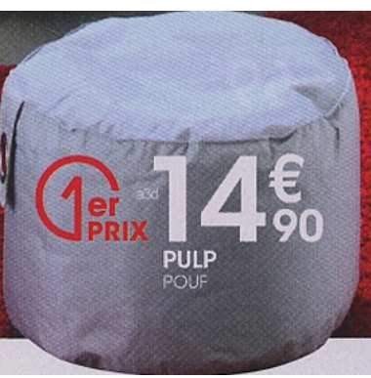 |  | 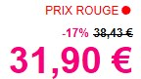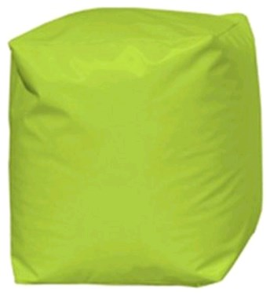
Ideal period for the stores | NONE - the is no se |  | ason for this product
Packaging Must be in one carton with informations drawings.or written very cle | manual instructions as clear as th  arly in french. A picture in color i |  | e one done for ikea furniture meanning with  s a real plus for sales
product description  Coating: polyester - Filling: polystyrene be  Want colors: white, red, black , pink, girs , green,  Mix of 6 colors in the offer - Dim approx. 40x40 | ad  brown . x40 cm | eleme | nts changing the price level
 | ad  brown . x40 cm | color
 | ad  brown . x40 cm | composition
additional information | None
Potential quantity | Around 4 € - 4500 pieces in a row - 6 colors
Mandatory standard
and request for None quality control

