Annex 1: Technical Specifications of Millet Seed
Projects (OSRO/PAK/901/CHA)

1. General information
a. Requirements by FAO
Crop common name | Crop scientific name | Variety name | Total quantity requested (MT) | Delivery date
Pearl Millet (Bajra) | Pennisetum glaucum | Bajra Super 1 (2006) or any equivalent variety | 30 MT | Last week of March, 2019

Varietal characteristics:
Characteristics parameters
 | Bajra Super 1
Variety type (OPV, Hybrid, Self-pollinated) | OPV
Days to maturity | 90-100 days
Grain/fruit colour | Pearly Amber White
Plant height/Length | 180-200 cm
Growth habits | Erect/upright
Specific resistance/tolerance to biotic factors (e.g. fungi; bacteria; viruses)* | -Resistant to Seedling & Foliar Blight, Leaf Spot and Head Mold  -free from all types of insect pests
Specific resistance/tolerance to abiotic factors (e.g. low/high temperature, frost, water-logging, low/high soil pH; etc.) | -pH range 6.5-9.5- Drought tolerant  -Temperature: 20 °C to 45 °C
List of countries/areas where the variety is successfully cultivated | Sindh, Pakistan
*Seed should be free from all types of insect pests

b. Offer by the bidder
Producer Company :
Country of production:

Crop common name | Crop scientific name | Variety name | Quantity offered (kg) | Price (PKR)
Pearl Millet (Bajra)
2. Technical information
Crop common name: Pearl Millet

 | Technical specifications required by FAO* |  | Actual characteristics of the seed offered  (to be filled by the bidder) | Comments
Varietal purity | 98% minimum | 97% minimum | %
Analytical purity | 98% minimum | 97% minimum | %
Germination | 70% minimum | 70% minimum | %
Moisture content | 12% maximum / Moisture for vapour proof container 8%maximum | 12% maximum /Moisture for vapour proof container 8%maximum | %
Seed Class/Category | Certified | Truthfully Labeled under Seeds (Truth-In-Labelling Rules, 1991)
Seed treatment  (when treated seed is required, product or products of treatment must be indicated. Treated seed must be dyed an unusual and unpalatable colour) | Product Name  Treated with Carbendazime active ingredients: 50% WP@1-2 gram/kg of seed |  | Product name
Phytosanitary import requirements of the importing country / country of final destination | Compliant

3. Packaging
 | Technical specifications required by FAO | Actual characteristics of the seed offered  (to be filled by the bidder)
Weight of each Pack | 20 Kg
Containers are marked with project number, variety name, germination rate, moisture content, weight, date of harvest, seed treatment used. All packages containing treated seeds must be clearly marked: "Not for human or animal consumption" and with the skull and crossbones symbol for poison.  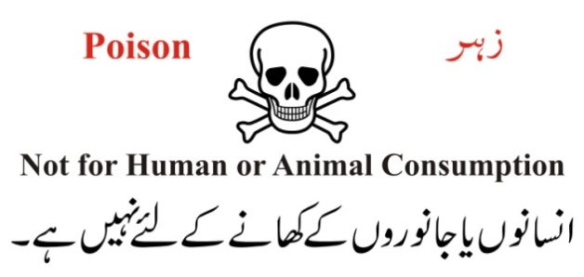 | Certified Seed:  For every crop/variety Containers are marked with project number, as well as tagged/labeled as per FSC&RD specifications of Certified Seed along with a copy of Testing Report (04 Form).  Truth-In- Labelling Seeds:  Each Container shall carry a label with information on it: 1. Lot No.  2. Crop/Species.  3. Variety.  4. Pure Seed %.  5. Germination %.  6. Other crop seeds %.  7. Weed seeds %.  8. Inert matter %.  9. Month/Year of Production.  10. Date of expiry.  (Additionally, Import details and Clarence from FSC&RD and Department of Plant Protection)  For seed treatment used. All packages containing treated seeds must be clearly marked: "Not for human or animal consumption" and with the skull and crossbones symbol for poison
Packaging type | Strong Woven Polypropylene Bag
Tags and logos | Project and Donor marking and "Not for human or animal consumption" in both Urdu and English, with skull and crossbones symbol for poison

4. Other information (to be filled by the bidder)
Is the seed consignment accompanied with a PHYTOSANITARY CERTIFICATE, fulfilling the phytosanitary import requirements of the importing country/country of final destination?
Does the offered seed lot contain GMO?
If yes, please provide a declaration on extent of GMO in the seed consignment

If the variety offered is not the one required in the specifications, please provide the key varietal characteristics of the seeds offered. These should include:

Crop common name

Variety name

Variety type (OPV, Hybrid, Self-pollinated)

Days to maturity

Grain/fruit colour

Plant height

Growth habit

Specify resistance/tolerance to biotic factors (e.g. fungi; bacteria; viruses)

Specify resistance/tolerance to abiotic factors (e.g. low/high temperature, frost, water-logging, low/high soil pH; etc.)

List of countries/areas where the variety is successfully cultivated

If the variety offered is not the one required in the specifications, please provide the key varietal characteristics of the variety offered (see page 4)
Varietal purity: the percentage of the pure seed that will produce plants that exhibit the characteristics of that specific crop variety.
Analytical purity: the percentage of the seed that is of the same crop species but not necessarily the same crop variety. - The impurities can include inert matter, weed seed, other crop seed and other varieties, however, within prescribed limits of certified seed.
Germination: the percentage of the pure seed with the ability to germinate and that can develop into normal seedlings under appropriate conditions of optimum moisture, temperature and light. Truthfully labelled seeds: The regulatory agency is not responsible for the direct supervision of seed production – the seed producer must ensure that the seed meets the minimum standards described on the label. Minimum standards (purity, germination etc.) for truthfully labelled seed may be determined by the state regulatory agency or left to the discretion of the seed producer. Consumers monitor adherence to standards and report failure to meet standards, while regulatory agencies oversee the situation and carry out spot checks. Enforcement is the responsibility of the courts or a regulatory agency
In case of INTERNATIONAL PROCUREMENT

