# GOVBUY ENQUIRY

报价截止时间：12月 1号

**一、Buyer（采购方）**

|  |  |
| --- | --- |
| Company name | Elite Textile Trading LLC |
| Address | 300 Spectrum Center Drive Suite 400，Irvine Ca 92618 |
| 中国苏州办公室 | 苏州市吴中区郭巷街道吴淞江大道111号天运广场5号楼21楼 |
| 电话 | 0512-65630708、17712662220、15306130295 |

**二、Supplier（供应商）**

|  |  |
| --- | --- |
| Company name公司名 |  |
| Address地址 |  |
| Contact联系人 |  |
| Tel联系电话 |  |

**三、Product（产品信息）**

|  |  |  |  |  |
| --- | --- | --- | --- | --- |
| NO. 编号 | ITEM  产品 | QUANTITY  数量 | UNIT PRICE  含税含到附近港口运费单价 | DELIVERY TIME交期 |
| 1 | 标志牌（4种） | 47,500个 |  |  |

Product description（英文+中文）：

Landowner Relations Signs 2020

Four (4) different signs for a total of 47,500 signs.

Quantities, Sizes, and Specifications are as follows:

Hunting By Permission Only

Quantity: 12,500

Size: 11.25” x 11.25”

Yellow high-density polyethylene, 0.24-gauge, black print

Access By Permission Only

Quantity: 25,000

Size: 11.25” x 11.25"

Yellow high-density polyethylene, 0.24-gauge, black print.

Safety Zone

Quantity: 5,000

Size: 7.5" x 11.25"

Yellow high-density polyethylene, 0.24-gauge, black print

Attention Sportsmen No Vehicles Beyond This Point

Quantity: 5,000

Size: 7.5” x 11.25"

White high-density polyethylene, 0.24-gauge, dark green print.

**2020年土地所有者关系标志**

四(4)种不同的标志，总共47，500个标志。

数量、尺寸和规格如下:

**Hunting By Permission Only 仅允许狩猎**

数量:12，500个

尺寸:28.575厘米*28.575厘米

材质：黄色高密度聚乙烯，0.24-gauge，黑色印刷

**Access By Permission Only 仅允许访问**

数量:25，000个

尺寸:28.575厘米*28.575厘米

材质：黄色高密度聚乙烯，0.24-gauge，黑色印刷。

**Safety Zone 安全地带**

数量:5000个

尺寸:19.05厘米*28.575厘米

材质：黄色高密度聚乙烯，0.24-gauge，黑色印刷。

**Attention Sportsmen No Vehicles Beyond This Point**

数量:5000个

尺寸:19.05厘米*28.575厘米

材质：白色高密度聚乙烯，0.24-gauge，深绿色印刷。

示例图片：

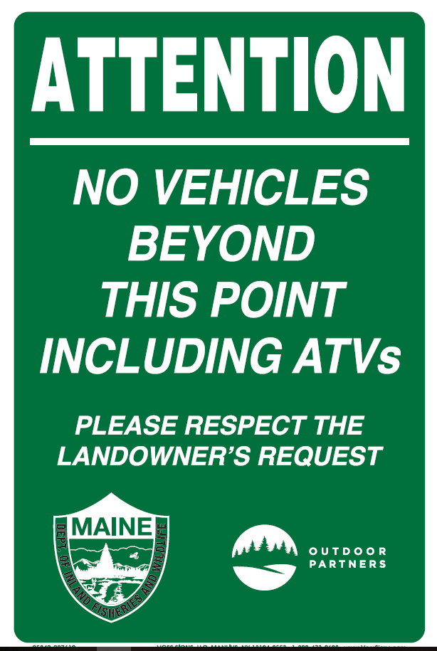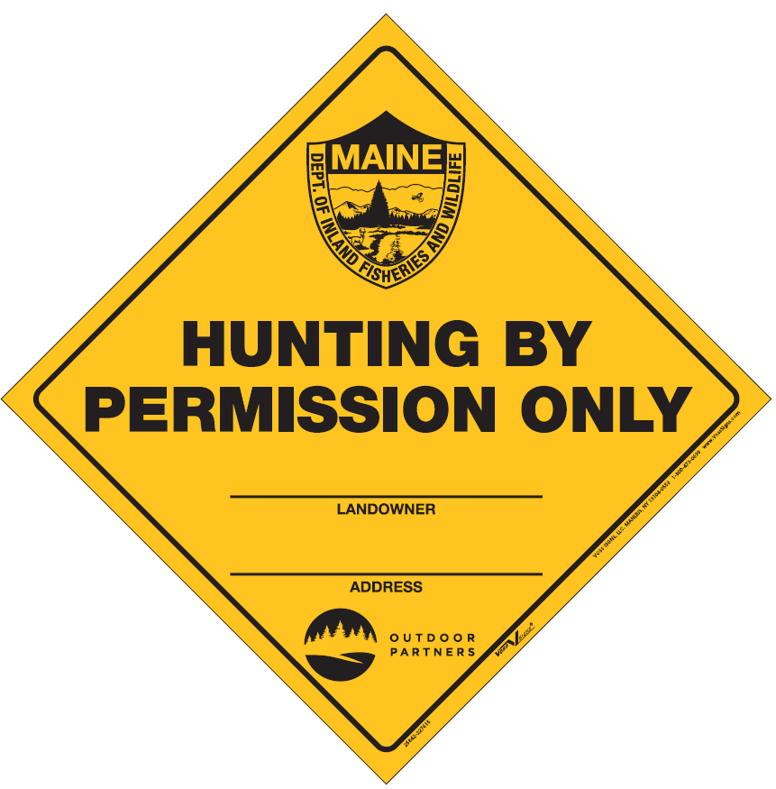

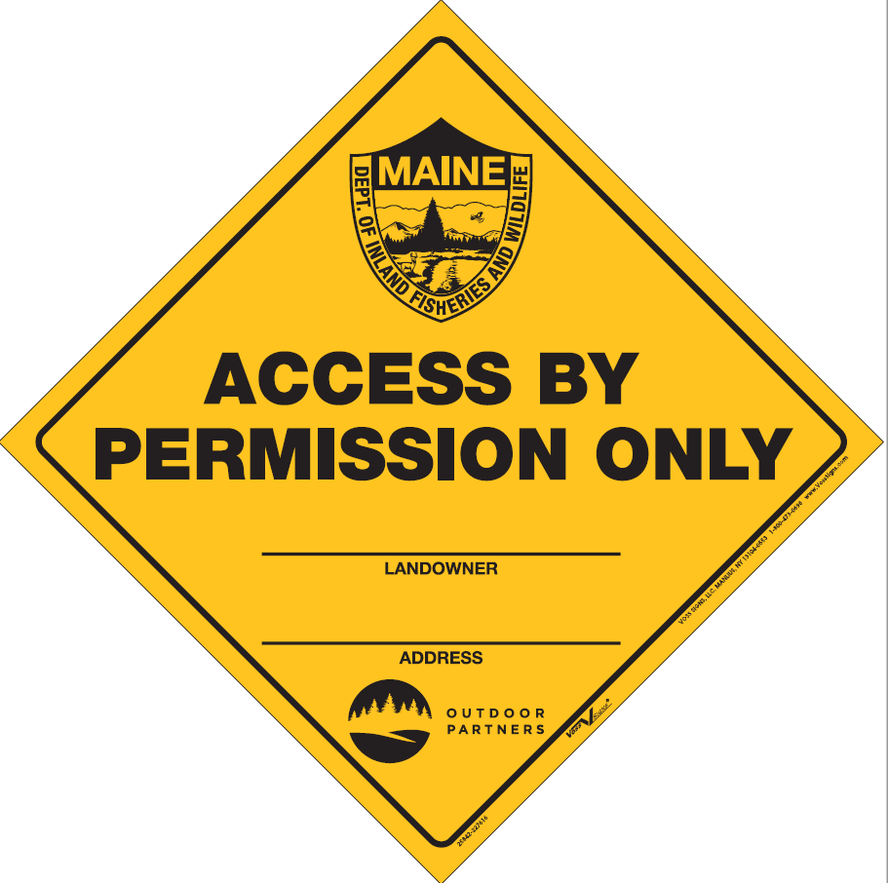

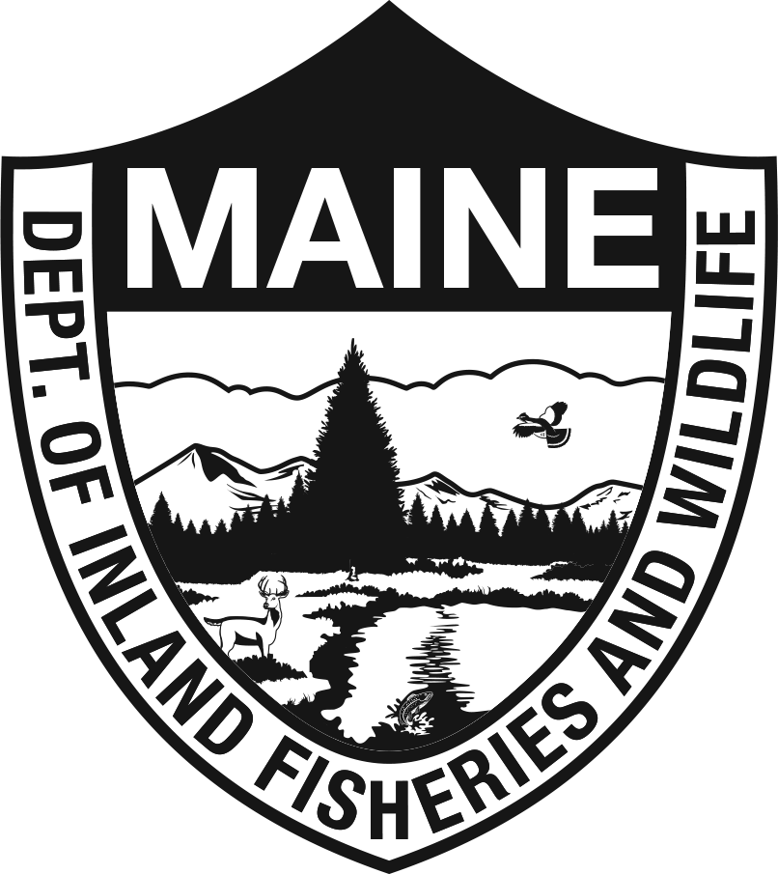

送货地址：Governor Hill Hatchery 82 Hatchery Rd Augusta,ME 04330 US

交期要求：1/13/2021

发货要求：一次发货

样品要求：无

**四、Remark（备注）**

|  |  |
| --- | --- |
| Packing包装方式： |  |
| G.W毛重 |  |
| Volume 体积 |  |
| HS code海关编码： |  |
| Date报价日期： |  |