# GOVBUY ENQUIRY

报价截止时间：12月12号

**一、Buyer（采购方）**

|  |  |
| --- | --- |
| Company name | Elite Textile Trading LLC |
| Address | 300 Spectrum Center Drive Suite 400，Irvine Ca 92618 |
| 中国苏州办公室 | 苏州市吴中区郭巷街道吴淞江大道111号天运广场5号楼21楼 |
| 电话 | 0512-65630708、17712662220、15306130295 |

**二、Supplier（供应商）**

|  |  |
| --- | --- |
| Company name公司名 |  |
| Address地址 |  |
| Contact联系人 |  |
| Tel联系电话 |  |

**三、Product（产品信息）**

|  |  |  |  |
| --- | --- | --- | --- |
| Country国家 | USA | State州 | PA |
| Department部门 |  | Solicitation编号 |  |
| Published发布 | 12.9 | Closing截止 | 12.15 |

|  |  |  |  |  |
| --- | --- | --- | --- | --- |
| NO. 编号 | ITEM  产品 | QUANTITY  数量 | UNIT PRICE  含税单价 | DELIVERY TIME交期 |
| 1 | Shirt, Men's Work, Short  Sleeve, V-Neck  男装衬衫，短袖，v领 | 6500件 |  |  |

Product description（英文+中文）：

PULLOVER WITHOUT CLOSURES OF ANY TYPE,

MATERIAL: 65% DACRON POLYESTER, 35% (+ OR - 5%) COMBED COTTON,

WEIGHT: 5 OUNCE TWILL FABRIC,

ONE (1) POCKET ON UPPER LEFT FRONT CHEST (BARTACK PROJECT), BOTTOM HEM APPROXIMATELY 1/2" TO BE WORN TUCKED IN OR OUT,

REINFORCED STITCHING: THREE (3) NEEDLE STITCHING AT ALL MAJOR PRESSURE POINTS, SIZE LABEL TO BE SEWN IN GARMENT.

DEPARTMENTS/AGENCIES TO SPECIFY COLOR, NECK AND SLEEVE SIZE FOR SHIRTS AT THE TIME ORDERS ARE PLACED.

没有任何类型样式的套头衫，  
面料:65%涤纶，35%(±5%)精梳棉，  
克重:5盎司斜纹织物(169.5克/平方米)  
左前胸上有1个口袋(加强缝线设计)，下摆大约1/2英寸(1.27厘米)缝边,可以在里面或外面，  
加强缝合:在所有主要压力处各有3道加强，尺寸标签要缝在衣服上。  
在下单时指定衬衫的颜色、领口和袖子尺寸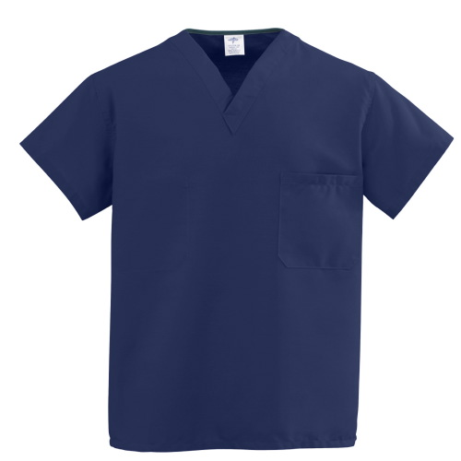

交期要求：自定

发货要求：（一次/按需发货）

样品要求：

**四、Remark（备注）**

|  |  |
| --- | --- |
| Packing包装方式： |  |
| G.W毛重 |  |
| Volume 体积 |  |
| HS code海关编码： |  |
| Date报价日期： |  |