斧头
Product family : GARDEN |  | Produ |  | ct type : HATCHET
联系: 亚洲采新REGINA |  | EMAIL: mira@ozeol.com  QQ: 2018536148
 |  | PICTURES
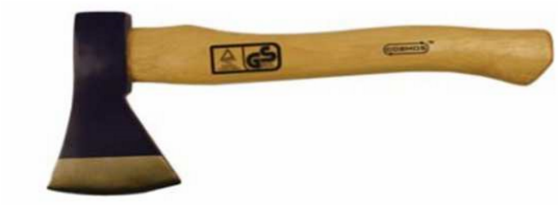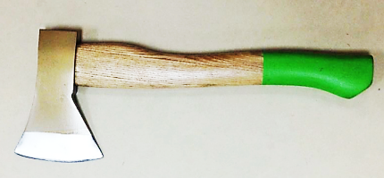 |  | 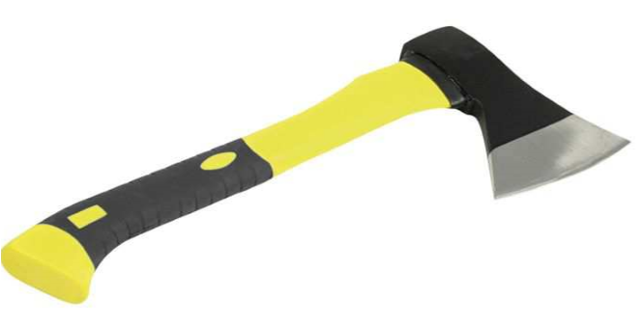 |  | 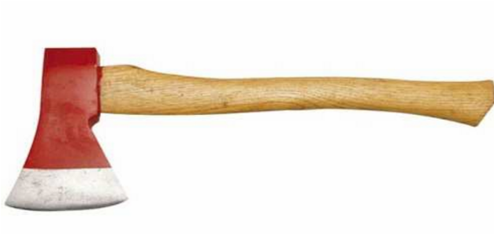
 | overall length:365mm
Product seasonality : | WINTER | Ideal sales period : |  | SEPTEMBER / FEBRUARY
Packaging details
 | Product description for example : |  | Product's | specificities modifying basic price level
 | Product description for example : |  | material
 | Product description for example : |  | handle
 | Product description for example : |  | weight
Additional information
Potential quantity
Mandatory standard and quality check request

