Technology Qualification & Requirement
1 specification for Cement Packing bags：
content | Sack features
Filled sack weight (kg) | 50
Material packed | PORTLAND CEMENT
A Length (mm) | 615$±0.5$
B Width (mm) | 495$±0.5$
C Patch height (mm) | 110$±0.2$
D Patch length(mm) | 385±0.5
E Valve depth (mm) | 170$±0.2$
F Valve height(mm) | 115±0.2
Valve Colour | Red
Valve orientation | Back left
Micro perforation: | Yes
Air Permeability | > 120 cu. M/50 mbar
Coating | 25 GSM ± 3 GSM
Bag strength | > 650 Newton in Warp direction
Bag weight | 83 GSM±2GSM

2、Detailed design of Packing bag：
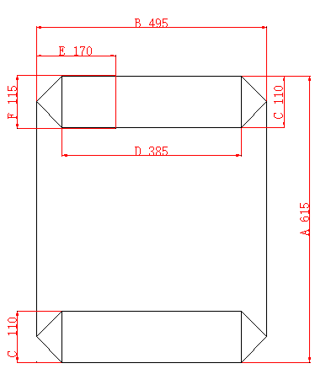

The final design and specification shall be in accordance with the client’s requirement.
3, Technical requirements
Product name: two-layer plastic woven bags

Color: It shall be made according to the design, format and color provided by the client

Format requirement: it shall be made in line with the requirements provided by the client, the mark shall be clear, correct and right color
- ≤100℃. The acceptable temperature: ≤100℃
- Damage rate shall be less than 3‰, bags damaged over that rate shall be provided by the contractor free of charge.
- Package type shall be 100 pcs/bundle, easy to pack, the package fee shall be included in the quotation.
- 1±0.02m Selecting 5 sample bags arbitrarily, these bags shall not break for over 8 times falling tests from 1±0.02m of height under the condition of ≤100℃ thermal treatment and loading 50±0.2kg sand.
- meet the national quality standards of Zambia.

