Specification Hobo #
Quantity: | 300 pcs | pcs per Carton: | tbd
Sample Lead Time: | 14 days | Carton size: | tbd
Production Lead Time: | 45 days | Carton weight: | tbd

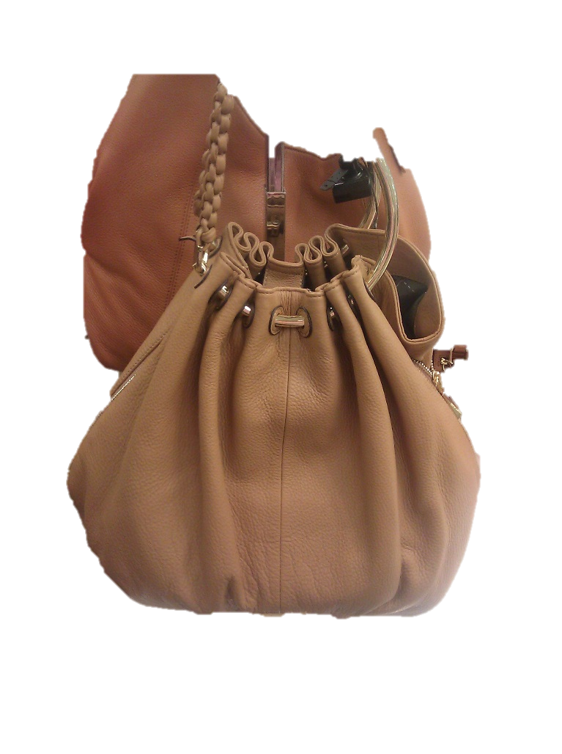
Specifications:
- Material:
  - Shell =PU Fabric pu布料
Zhong Ye Leather- PUDE 90
中业皮革有限公司-pude 90色卡
Color # 1 Black 序号1 黑色
Color # 6 Beige 序号2 肤色
  - Liner = 210D Pu color 52-Red
里料：宏基布行 210D色卡序号52-红色
  - <90ppm Lead
  - 含铅量小于90PPM Lead

- Color = Black , Beige
- 颜色：黑色 ，肤色
- Hardware: 配件
- Buckles Silver for black and Gold for Beige to connect handle
- 扣用在黑色包是银色，用在肤色包是金色，并且是提手的部分是链接的
- Inside: 内部
1 zip pocket in back
包里有拉链袋，规格如下：
Dimension: 7” W x 5”H
2 elastic pockets in front
包外有个松紧袋，尺寸如下
Dimension: 5” W x 5”H
- Trim:铺料
Braid handles in same material
提手和包的材料一致
Tie and knot for closure
如图，
7. Dimension:包的尺寸：
17.5” L x 12” H x 4.5” D

