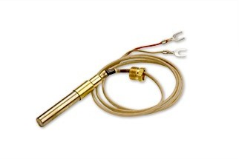

1950-532

Robertshaw® thermopiles are the industry leader for gas appliance applications. Their primary function is to ensure a standing pilot light is operative so that on a call for heat, the main burner gas will be properly ignited. Thermopiles are placed in gas applications to detect the existence of a flame for safety purposes by shutting off the potential gas flow to a burner. A thermopile is the assembly of many thermocouples to increase the millivolt output. Robertshaw thermopiles have two types of connections: coaxial and two-wire spade connectors.

The 1950 thermopiles, also known as TP-75, are two-wire spade connectors. The 1951 thermopiles, also known as CP-2 (500-600 millivolts) are coaxial connectors.

The 1950 and 1951 Series Thermopiles (pilot generators) are designed for use on self-powered gas control systems. They can be used to replace similar competitive devices.

Features and Benefits

* Easy burner installation with attached threaded nut
* Stainless steel outer jacket for long life and resistance to heat blistering
* Combination of copper and nickel alloys for good electrical conductivity
* Mica washer to insulate from shorting conditions
* Various lengths available for multiple applications
  + ATTRIBUTES

# Series Application 1950 & 1951 Thermopiles

**Lead Length 36"**

**Connection Type Two Lead**

**Electrical Rating 250mV - 750mV AC**

公司网址

https://www.robertshaw.com/zh-CN/ProductDetail.aspx?id=2147493746