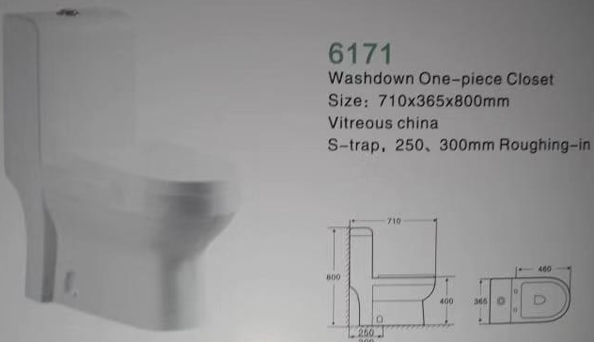

**FOSHAN AIRSTO KITCHEN & BATH CO.,LTD**

