Ruram farm has a total area of 500 hectares and is favorably located near Tiga dam. We plan to cultivate rice , maize, soybean, wheat and vegetables on this farm. We are targeting multiple crop cycles every year and are looking to set up an irrigation system to support dry season farming.

The proposed concept for the irrigation system and the system design are discussed below:

Irrigation system concept
- The farm will have three types of irrigation system to support different crops.
- The entire area is divided in 5 blocks of around 100 ha each
- There will be 5 pumping units for 5 blocks, each of around 100 ha.
- For paddy, hydrant outlets with valves will be provided at grid of around 150mtr X 150mtr for flooding.
- For wheat, maize and soybean, sprinkler guns system with shiftable laterals and permanent pipelines with outlets. The laterals and guns will be shiftable.
- For vegetables drip irrigation system will be used.

Requirements
- Please provide a quotation for the entire 500 hectares based on the design and material list mentioned below. Please breakout the quotation to include per unit cost of all parts.

- Please mention weight per running meter for all pipes.

- If you do not manufacture any particular item listed below, please suggest appropriate changes in the design to suit your manufacturing capabilities and quote for the same.

- For pumping unit, please mention the HP rating and brand of the pump you recommend.

- Please mention ex-factory rate and mention separately total number of containers and freight charges for delivery to Lagos, Nigeria (TinCan Island or Apapa port).

- Please mention delivery and installation timeline.

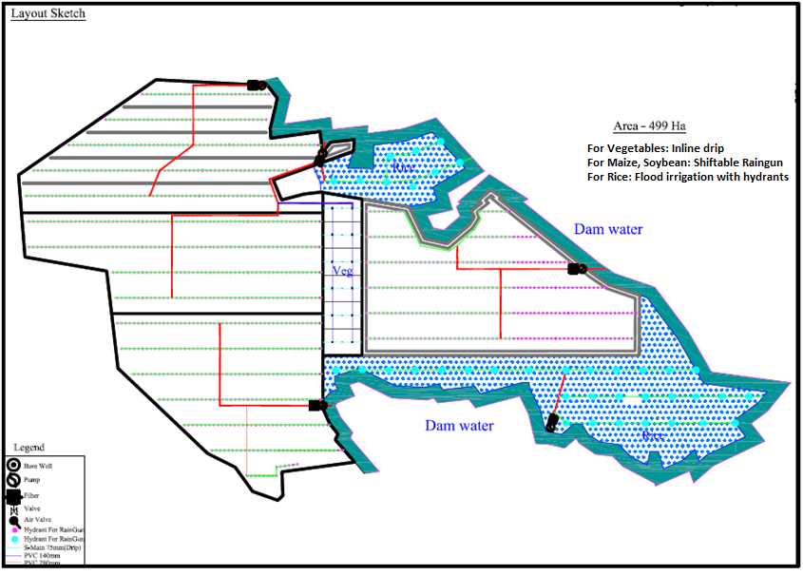
Irrigation System Design

Material List

