Cable Data Sheet

Product information
Description Cable 1P 20 AWG SHLD+1C18 AWG+2C16 AWG PVC JACKET
Special characteristics RoHS compliant

Cable construction
Conductor | Number of conductors | Twisted Pair 1 2
Conductor | Material | CuSn
Conductor | Wire gauge | 20 AWG 18 AWG 16 AWG
Conductor | Stranding | 10/30 AWG 16/30 AWG 26/30 AWG
Conductor | Nominal conductor diameter | 0.036” 0.046” 0.059”
 | Material | PE Foam PVC RoHS
 | Nominal thickness | 0.025” 0.025” 0.020”
Insulation | Nominal wire diameter | 0.086” 0.096” 0.099”
Insulation | Color | Brown & White | Blue Black &Red
Twisted Pair Shield | Tape | Aluminum Mylar
Twisted Pair Shield | Drain | TC 24 AWG STR 7/32
Other | Fillers | Paper and Polyvinyl Chloride(PVC)RoHS
Other | Separator | Tissue Paper
Jacket | Material | Polyvinyl Chloride(PVC)RoHS
Jacket | Nominal thickness | 0.072”
Jacket | Nominal outside diameter | 0.445”±0.010”
Jacket | Color | Black

Jacket print | HARTING,INC1PR20 AWG SHLD 60℃300V,1C18&2C16 AWG 600V 105℃  P/N 73550465972 SUN RES ROHS SF50C(SEQUENTIAL IN METERS)
Certifications | Communication Cables | UL444/CSA C22.2 No.214
Certifications | Appliance Wiring Material | UL758/CSA C22.2 No.210.2
Physical Characteristics | Weight approx. | 0.147 Kg/m

Performance characteristics
Voltage Twisted Pair 300V/Conductors 600V
Electrical | Capacitance(Pair) | 42 pF±5
Electrical | Twisted Pair impedance | 120 Ohms±15
Electrical | Maximum resistance in Ohms/km@20℃ | 20 AWG/  33.8 | 18 AWG/  23.5 | 16 AWG/ 14.1
Mechanical | Flammability rating | CSA FT2
Mechanical | Minimum bend radius | 2.7 inches
Mechanical | Temperature range | 60℃ Pair,-20℃/105℃

ALUMINUM MYLAR

JACKET

FILLER

CONDUCTOR

TISSUE PAPER

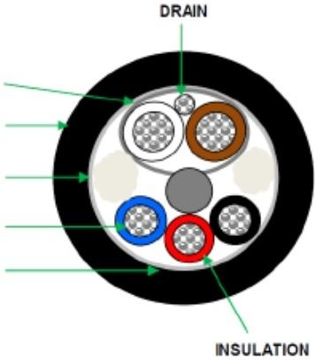

DRAWING FOR REFERENCE ONLY

