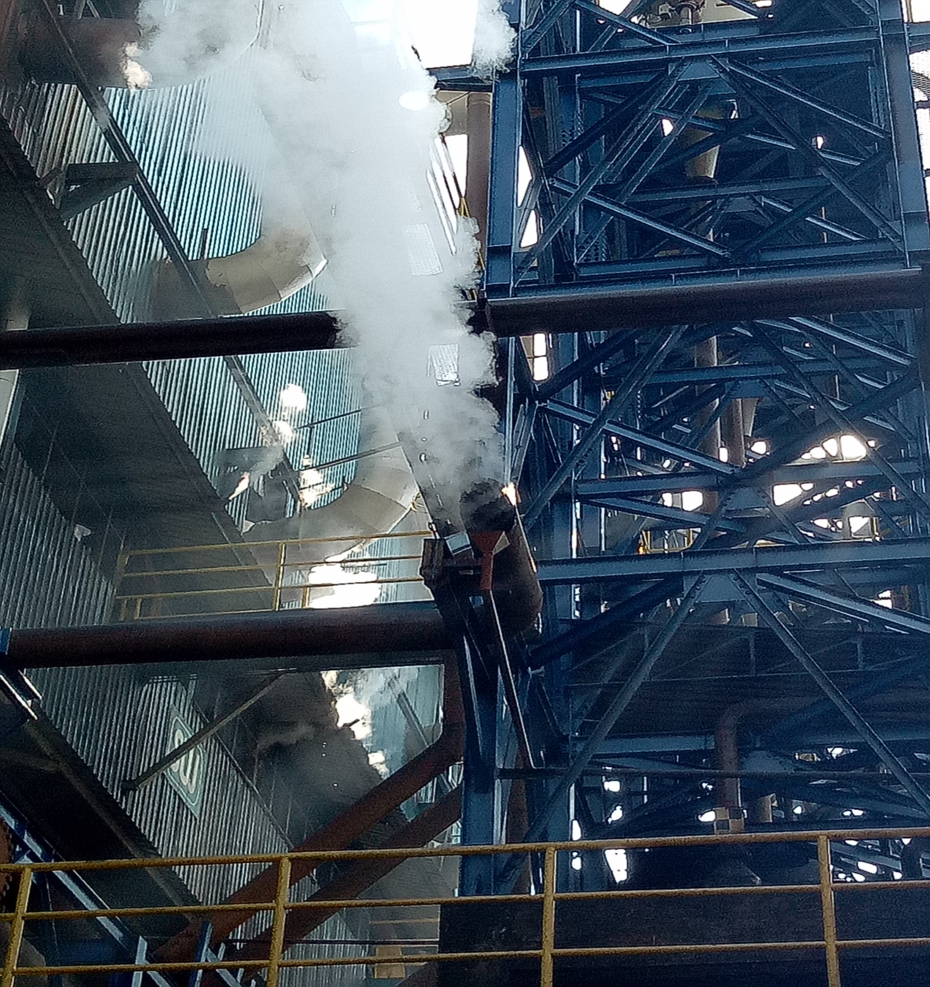

For Steam blow off from Exhaust pipe of Process
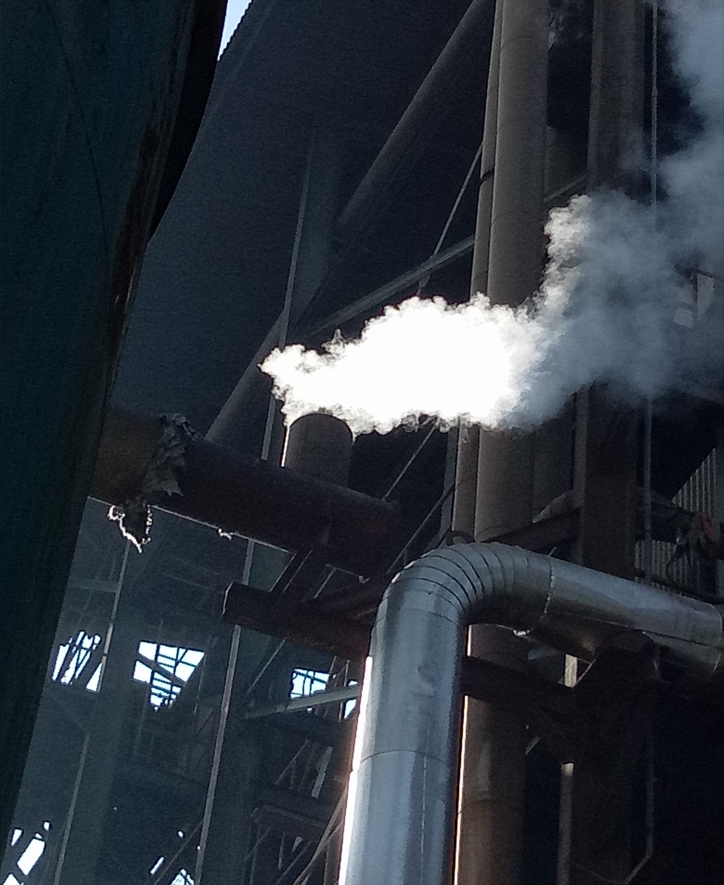

For Steam Blow Off from Exhaust pipe of Turbine

