Items | Pictures/specifications | Quantity
PROJECTOR Astrolux ED500  PROJECTOR Astrolux ED500  Type: 4ME500 / 1XHPL-N400W  REF: 06945300 | 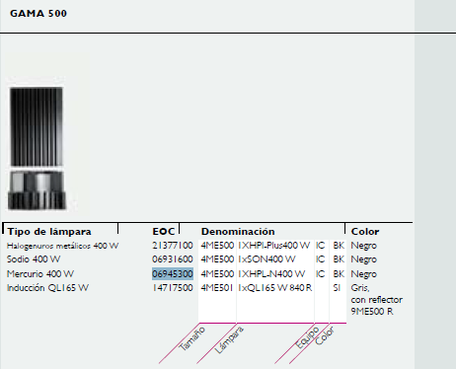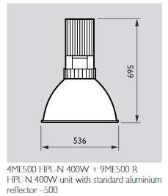  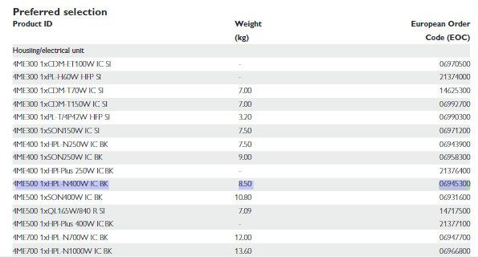 | 60 PC
Astrolux ED500 projector Astrolux ED500 Projector  Type: 4ME500 / 1XQL-165W840RSI  REF: 14717500 | 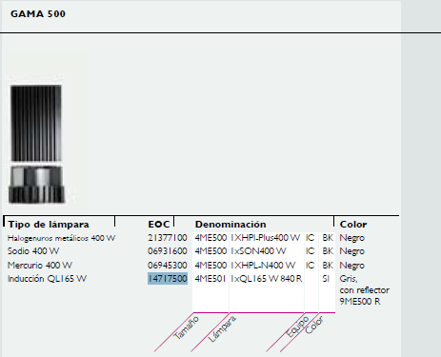  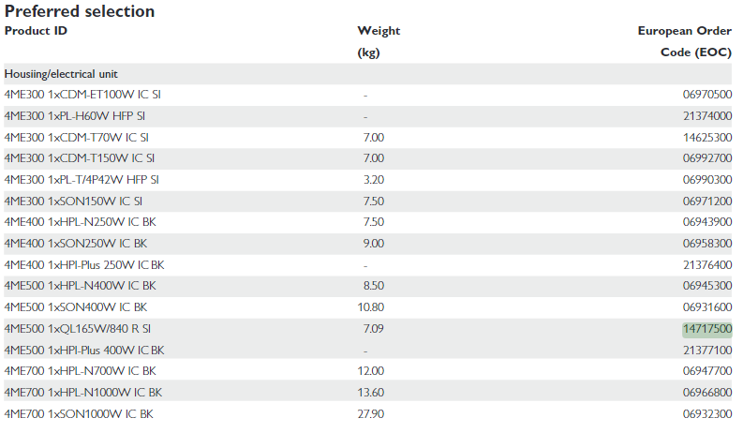 | 15 PC
Aluminum reflector 9ME500R Aluminum reflector 9ME500R  REF: 53108099 | 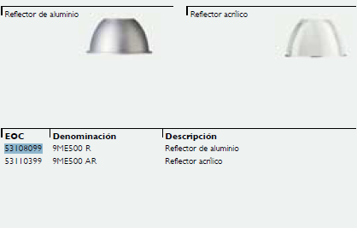  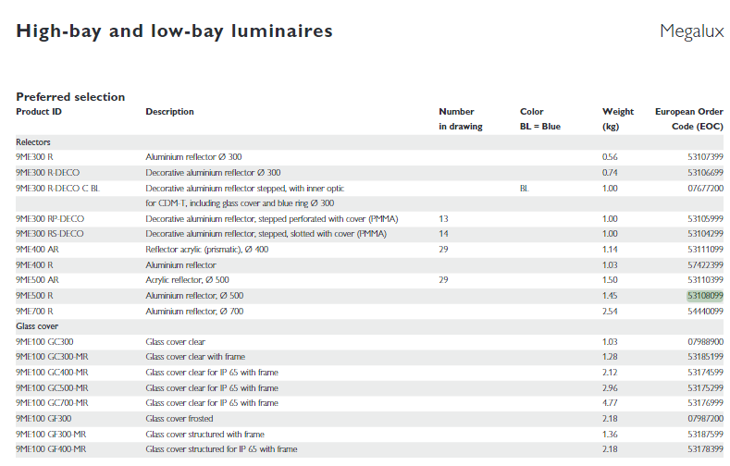 | 60 PC
Glass closure on metal frame  Glass closure on metal frame for aluminum reflector  IP65 9ME 100 GC 500-MR  REF: 53175299 | 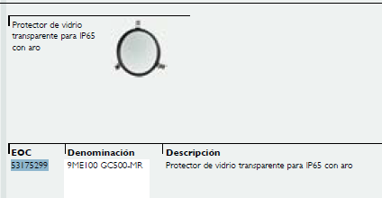  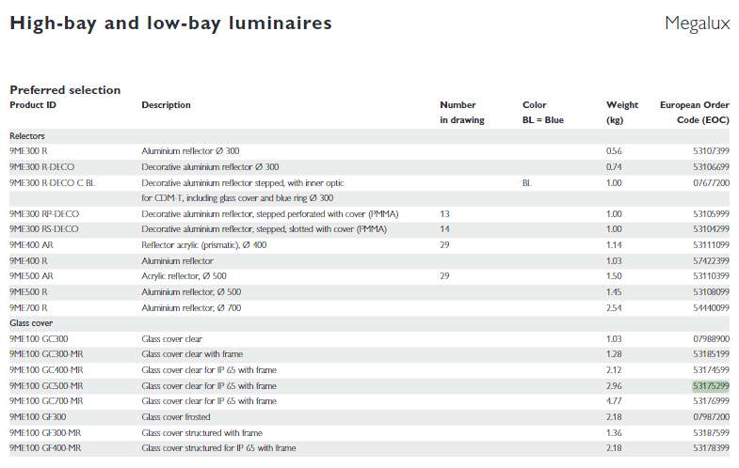 | 60 PC

