# GOVBUY ENQUIRY

报价截止时间：11月 30号

**一、Buyer（采购方）**

|  |  |
| --- | --- |
| Company name | Elite Textile Trading LLC |
| Address | 300 Spectrum Center Drive Suite 400，Irvine Ca 92618 |
| 中国苏州办公室 | 苏州市吴中区郭巷街道吴淞江大道111号天运广场5号楼21楼 |
| 电话 | 0512-65630708、17712662220、15306130295 |

**二、Supplier（供应商）**

|  |  |
| --- | --- |
| Company name公司名 |  |
| Address地址 |  |
| Contact联系人 |  |
| Tel联系电话 |  |

**三、Product（产品信息）**

|  |  |  |  |  |
| --- | --- | --- | --- | --- |
| NO. 编号 | ITEM  产品 | QUANTITY  数量 | UNIT PRICE  含税单价 | DELIVERY TIME交期 |
| 1 | Floss Sticks Adult成人牙线棒 | 15000包 |  |  |
| 2 | Floss Sticks Children儿童牙线棒 | 5000包 |  |  |

Product description（英文+中文）：

**Floss Stick, Adult**

Must meet the following Specifications:

• Must be Full-Sized Adult Floss Sticks

• 90 count/pkg

• Floss Sticks must be plastic.

• Floss Sticks to be single strand.

• Flavors to be Mint or Unflavored.

• Individually wrapped Floss Sticks will not be accepted.

•3-Packs of Floss Sticks will not be accepted.

**Floss Stick, Children’s**

Must meet the following Specifications:

• Must be Full-Sized Children’s Size Floss Sticks

• 40 count/pkg

• Floss stick must be plastic.

• Floss sticks to be single strand

• Flavors to be Bubble gum, Grape, or other Fruit Flavor

• Mint flavor will not be accepted.

• Individually wrapped Floss Sticks will not be accepted.

•3-Packs of Floss Sticks will not be accepted.

成人牙线棒

必须满足以下规格：

•必须是足尺的成人牙线棒

•90个/包,15000包

•牙线棒必须是塑料的。

•牙线棒为单股。

•有薄荷味或无味的味道。

•不接受单独包装的牙线棒。

•不接受3个包装牙线棒。

儿童牙线棒

必须满足以下规格：

•必须是足尺的儿童牙线棒

•40个/包,5000包

•牙线棒必须是塑料的。

•牙线棒为单股

•口味为泡泡糖，葡萄或其他水果口味

•不接受薄荷味。

•不接受单独包装的牙线棒。

•不接受3个装牙线棒。

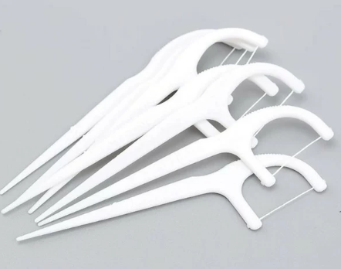

图片来源于网络，仅供参考

送货地址：GNWT Warehouse

415 Byrne Road

Yellowknife, NT, X1A 2X8

交期要求：1.15之前

发货要求：（一次发货）

样品要求：

**四、Remark（备注）**

|  |  |
| --- | --- |
| Packing包装方式/箱规 |  |
| G.W单箱毛重 |  |
| Volume 体积 |  |
| HS code海关编码： |  |
| Date报价日期： |  |