# GOVBUY ENQUIRY

报价截止时间：12月 22号

**一、Buyer（采购方）**

|  |  |
| --- | --- |
| Company name | Elite Textile Trading LLC |
| Address | 300 Spectrum Center Drive Suite 400，Irvine Ca 92618 |
| 中国苏州办公室 | 苏州市吴中区郭巷街道吴淞江大道111号天运广场5号楼21楼 |
| 电话 | 0512-65630708、17712662220、15306130295 |

**二、Supplier（供应商）**

|  |  |
| --- | --- |
| Company name公司名 |  |
| Address地址 |  |
| Contact联系人 |  |
| Tel联系电话 |  |

**三、Product（产品信息）**

|  |  |  |  |  |
| --- | --- | --- | --- | --- |
| NO. 编号 | ITEM  产品 | QUANTITY  数量 | UNIT PRICE  含税含运单价  （到就近港口） | DELIVERY TIME交期 |
| 1 | 条形码标签 | 66万个标签  （220卷） |  |  |

Product description（英文+中文）：

The contractor shall provide 660,000 (3,000 per roll) barcode labels as outlined in attached specifications.

1. See the attached photo of one of our current barcodes on an object.
2. The products would be applied to archival paper. c. Barcodes would be stored permanently in an indoor museum environment, which is kept at approximately 60 degrees Fahrenheit and 50% relative humidity. They will also need to withstand occasional exposure to negative 80 degrees Celsius.

承包商应提供所附规格中概述的660,000（每卷3,000）条形码标签。

A 请参阅我们当前一个条形码的附图。

B 这些产品将用于档案文件。

C 条形码将永久保存在室内博物馆环境中，该环境保持在大约60华氏度和50%的相对湿度。 他们还需要承受偶尔接触负80摄氏度。

Barcode labels *must* meet all the following specifications for use in the USNA herbarium:

**Size:** 1.680 (width) x 0.250 (height) inches

**Encoding type:** Code 128

**Stock:** Polyester, white (3 mil thickness)

**Finish:** Polyester, matte (1 mil thickness)

**Adhesive:** Acrylic, low temperature (1 mil thickness)

**Rolls:** 3,000 barcodes per roll

**Style:** Rounded edges; barcode bleeds off the top of the label; human-readable text will appear underneath the barcode

**Numbering:** Encoded data must begin with the uppercase letters “NA” followed by seven digits (starting with number “0150001” to ensure continuity with previous batches); the human-readable text will include a hyphen between the “NA” and the seven digits, but the barcode itself must not encode this hyphen.

条形码标签必须符合以下所有规范才能在USNA植物标本室中使用：

尺寸：1.680（宽）x 0.250（高）英寸(4.2672*0.635cm)

编码类型：Code 128

材质：聚酯纤维，白色（厚度3密耳）

表面处理：哑光聚酯纤维（厚度为1密耳）

粘合剂：丙烯酸，低温（厚度1密耳）

每卷3,000条码

款式：圆润的边缘； 条码从标签顶部渗出； 可读文本将出现在条形码下方

编号：编码数据必须以大写字母“ NA”开头，后跟七个数字（以“ 0150001”开头，以确保与先前批次的连续性）； 可读文本将在“ NA”和七位数字之间包含连字符，但条形码本身不得对此连字符进行编码。

1) What is the width of the roll that the labels are on?

A: 5 centimeters across.

2) What is the length between the top of the label to the top of the following label on the roll?

A: 1 centimeter from the top of one barcode to the top of the next (with 3 millimeters of empty space between each barcode).

3) Is the excess material around the die cut label removed from the roll before they are sent to you or is it still on the rolls when you receive them?

A: Only the barcode (die cut) should remain on the roll upon arrival. See the attached photo (picture 2 for an example.

1. 每卷5cm宽
2. 从一个条形码的顶部到下一个条形码的顶部距离1厘米（每个条形码之间有3毫米的空隙）。
3. 只有条形码（模切）应该保持在卷上。 见附图。

以卷为单位报价

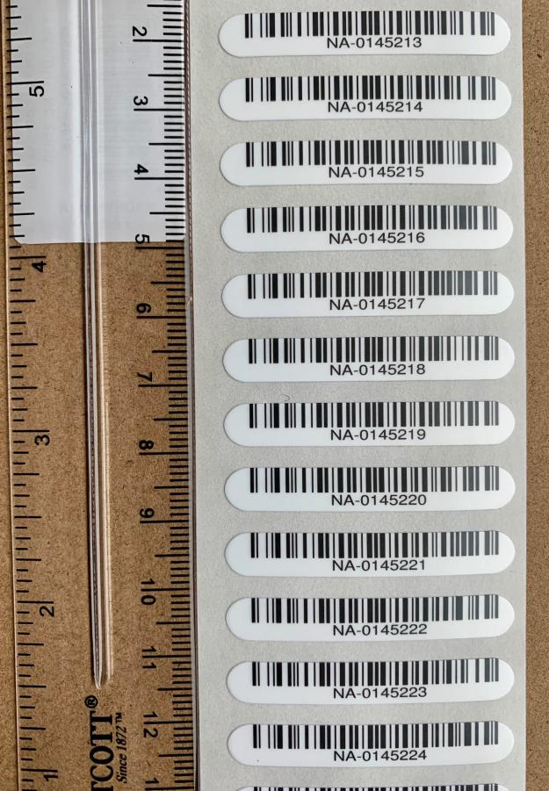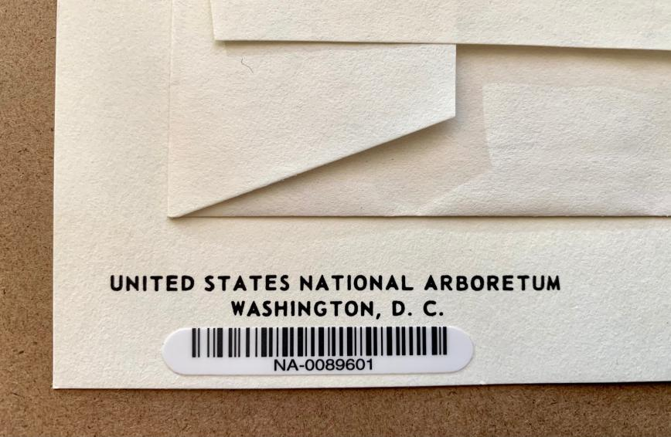

交期要求：50天

发货要求：一次

样品要求：

**四、Remark（备注）**

|  |  |
| --- | --- |
| Packing包装方式： |  |
| G.W毛重 |  |
| Volume 体积 |  |
| HS code海关编码： |  |
| Date报价日期： |  |