# GOVBUY ENQUIRY

报价截止时间：2020/12/15

**一、Buyer（采购方）**

|  |  |
| --- | --- |
| Company name | Elite Textile Trading LLC |
| Address | 300 Spectrum Center Drive Suite 400，Irvine Ca 92618 |
| 中国苏州办公室 | 苏州市吴中区郭巷街道吴淞江大道111号天运广场5号楼21楼 |
| 电话 | 0512-65630708、17712662220、15306130295 |

**二、Supplier（供应商）**

|  |  |
| --- | --- |
| Company name公司名 |  |
| Address地址 |  |
| Contact联系人 |  |
| Tel联系电话 |  |

**三、Product（产品信息）**

|  |  |  |  |
| --- | --- | --- | --- |
| Country国家 | USA | State州 | WA |
| Department部门 |  | Solicitation编号 |  |
| Published发布 | 2020/12/11 | Closing截止 | 2020/12/15  10:00 AM |

|  |  |  |  |  |
| --- | --- | --- | --- | --- |
| NO. 编号 | ITEM  产品 | QUANTITY  数量 | UNIT PRICE  含税含运单价 | DELIVERY TIME交期 |
| 1 | COVERALL  工作服  尺码：S | 500件 |  |  |

1、Product description（英文）：  
COVERALL

Size: Small with long sleeves (Sized to be worn over clothes)

Neck: 14-14.5

Chest: 34-36

Waist: 28-30

Sleeve: 30-32

Lightweight 100% 9 ounce weight Cotton.

Flame Resistant, even with repeated laundering.

Must meet the following requirements, ASTM F1506-02A, and ASTM F1959M/F1959M-99.

Green in Color.

Fabric is Anti-static.

Rot and mildew resistant.

Primary Protection for low heat and minor spark operations.

Secondary Protection in high heat or open flame situations.

Hidden from site: Front snap closures. (No Zippers)

Hidden from site: At Wrist; Right and left sleeve snap closures.

Hidden from site: Right and left leg 4 snap closures for easy removal of coveralls.

Inside left breast pocket.

2 Rear hip pocket.

2 Set-in hip pockets plus side vents that let you access your pants pockets.

SIZE: SMALL

COLOR: LIGHT GREEN

FLAME RESISTANT MADE OF LIGHTWEIGHT COTTON (9 OZ.)

EVEN WITH REPEATED LAUNDERING; FABRIC IS ANTI-STATIC ROT AND MILDEW RESISTANT

PRIMARY PROTECTION FOR LOW HEAT AND MINOR SPARK

OPERATIONS SECONDARY PROTECTION IN HIGH HEAT OR OPEN

FLAME SITUATIONS CONSISTS OF HIDDEN FROM SITE FRONT SNAP CLOSURES

WITH HIDDEN FROM SITE SNAPS ON BOTTON PART OF THE LEFT AND RIGHT LEGS AND SLEEVES

HAS INSIDE LEFT BREAST POCKET AND TWO BACK POCKETS MEETS ASTM D6413-99 SAFETY STANDARD FOR FIRE RETARDANT CLOTHING

2、产品描述（中文）：

产品：防护服

颜色：浅绿

尺码：S码，衣领14-14.5英寸（35.56-36.83cm），胸围34-36英寸（86.36-91.44cm），腰围28-30英寸（71.12-76.2cm），袖长30-32英寸（76.2-81.28cm）

材质：轻质100%的棉 ,9盎司/平方码重（305.1gsm）

特征：阻燃，反复洗涤后还会阻燃；织物防静电；抗腐、防霉

资质：必须符合ASTM F1506-02A, ASTM F1959M/F1959M-99，符合ASTM D6413-99阻燃安全标准。

性能：首先在低热量和小火花的工作环境中起到保护作用，其次在高温或明火环境下也要起到保护作用

隐藏部位：前面可快速闭合（不用拉链），手腕处左右两边的袖子和左右腿这4个部位也可以快速闭合，这样方便快速脱掉工作服

口袋：左胸部位有个内袋，臀部后面有两个口袋，前面是两个内置式口袋，口袋侧面是开口，这样利于插进口袋。

参考图片：

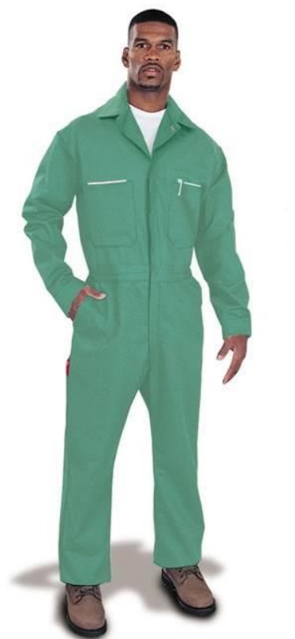

参考类型：MAGID GLOVE P/N: 1840

<https://www.magidglove.com/Magid-SparkGuard-1840-Green-Flame-Resistant-Coveralls-1840M.aspx>

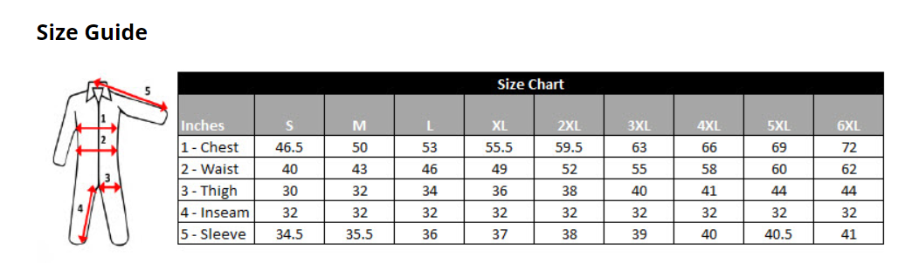

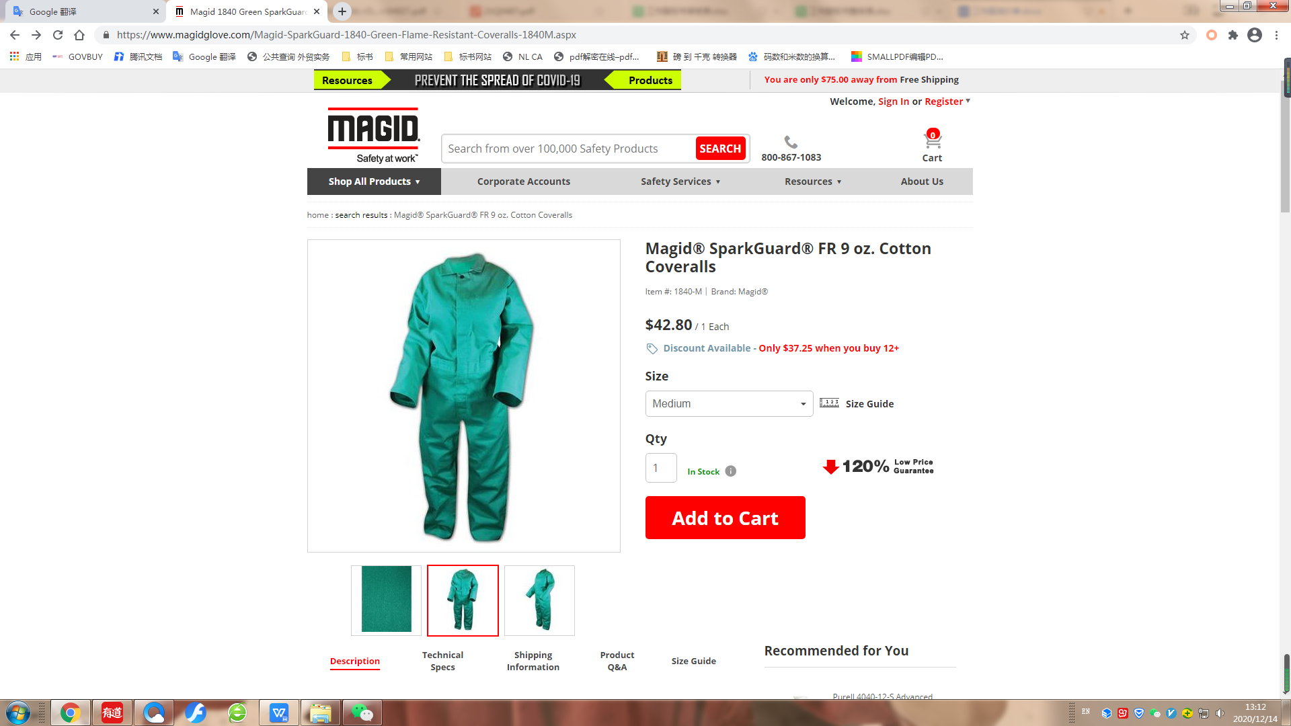 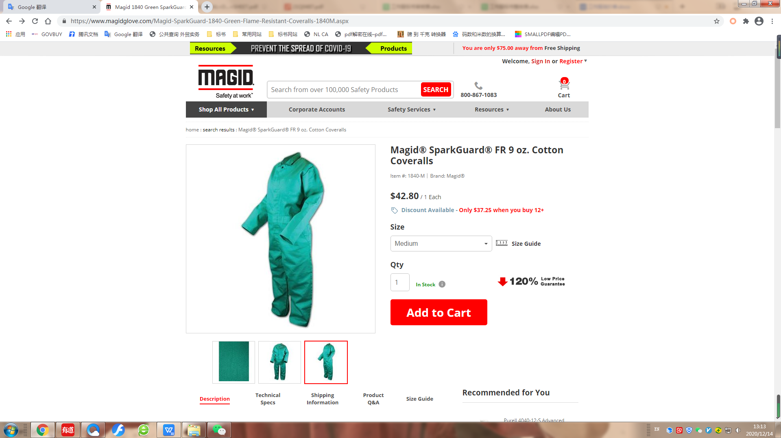

交期要求：2021/1/29或自定

发货要求：一次发货

样品要求：

**四、Remark（备注）**

|  |  |
| --- | --- |
| Packing包装方式： |  |
| G.W毛重 |  |
| HS code海关编码： |  |
| Date报价日期： |  |