鋸木架
联系: 亚洲采新 REGINA
EMAIL: mira@ozeol.com
QQ: 2018536148
Product family : GARDEN | Produ |  | ct type : SAWBUCK
 | PICTURES
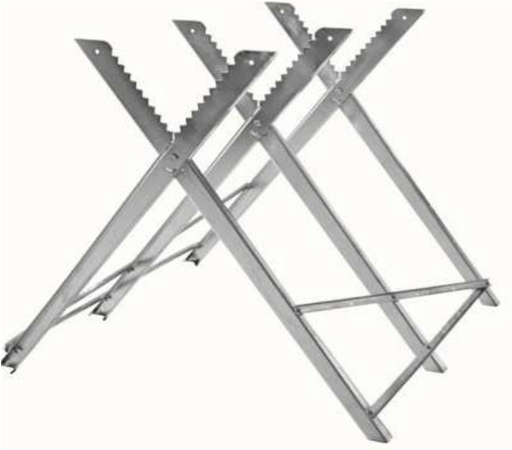 | 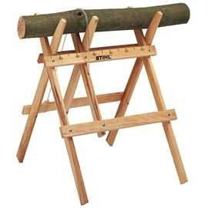 |  | 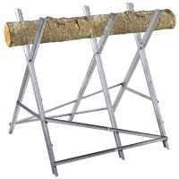
these products may  The important's informations : mate | French market details be found in specialized's stores, rial (wood, steel), size, cut's dia |  | GSB, GSA.  meter (section), folding, load
Product seasonality : AUTUMN / WINTER | Ideal sales period : |  | OCTOBER / NOVEMBER
Packaging details | carboard box with picture and produ |  | ct's informations.
Product description for example : |  | Product's | specificities modifying basic price level
Product description for example : |  | material
Product description for example : |  | size
Product description for example : |  | load
Additional information
Potential quantity
Mandatory standard and quality check request

