Item : Shoe Bag鞋袋
Description : The Shoe bag with a main zipped compartment (See below shoe bag sample picture)
描述： 一个拉链主袋+ 手提
Dimension : About 35 cm x 20 cm x 15 cm
尺寸：35*20*15cm
Material : 600D
材质：600D 涤纶
Preferred colour : Blue
颜色; 蓝色款
Logo : PUB Family Day logo (See below logo sample picture)
Logo： 如图尺寸9*5cm
Quantity: 3,500pcs
数量：3500pcs
Shoe Bag Sample Picture :
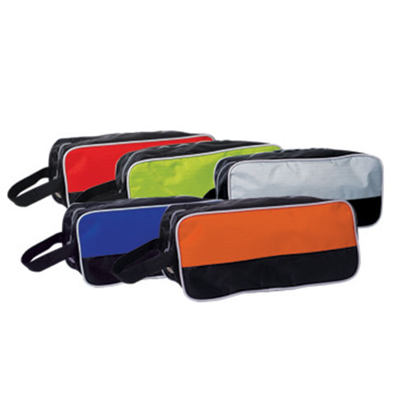

Logo 图片


